
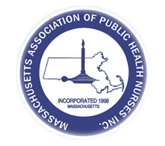
Massachusetts Association of Public Health Nurses
28th Annual Conference
Wednesday, May 13, 2026
Marriott Downtown Springfield
2 Boland Way, Springfield, MA 01115
“Building Resilience in Public Health Nursing”

4:00 PM Hotel Registration for Overnight Accommodations Check-In
Guests are able to check-in earlier if room is available, luggage can be stored
3:00-5:00 PM Registration: Check-In & Pick-Up Badges (Keep Badges for BOTH days)
4:00-5:00 PM Reception, Grazing Table & Cash Bar
5:00-5:15 PM Introduction to the Conference
5:15-5:45 PM Presentation: Adriene Worthington, M.Ed., RDN, American Heart Association, “Community Impact Initiatives"
5:45-6:45 PM Dinner & Cash Bar
6:45-8:30 PM Presentation: Michael Hugo, JD, MAHB, “Vaccines: Who's Calling the Shots?”
8:30-9:00 PM Socializing, Networking, Cash Bar, Dance Party

